DirectX 11 Tutorial 16 Part 1 – Lighting, Reflections and Cube Mapping

This week's tutorial focuses on shaders.

You are required to:

1. Ensure you have completed week 15 parts 1 and 2 and understand the code you have produced.
2. complete the diffuse light vertex shader
3. draw the box with diffuse light

Using your solution to last weeks tutorial (week 15 parts 1 and 2)

Review the week 15 & 16 lecture notes and complete the following tasks:

Task 2

* Add code to basic_lighting_vs - Calculate normal and output colour

Task 3

* Add Code to Render the Box

Draw the box.

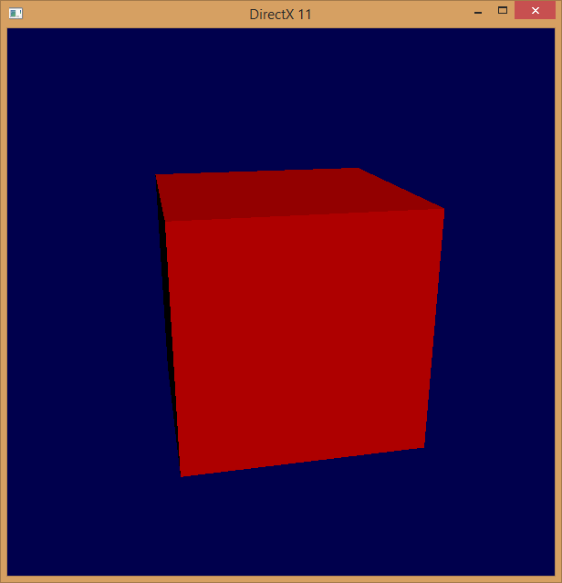

Screen shot of required outcome.

Part 2- Per Pixel Lighting Shaders

You are required to:

1. complete the vertex transformations in "per_pixel_lighting_VS.hlsl"
2. complete the per pixel diffuse lighting calculation in "per_pixel_lighting_PS.hlsl"
3. complete the per pixel specular lighting calculation in "per_pixel_lighting_PS.hlsl"

Review the week 16 lecture notes "Lecture 16a - Per Pixel Lighting " and complete the following tasks:

Task 4

This task requires changes to the "per_pixel_lighting_VS.hlsl" shader

Search the source code for the comments:

Add Code Here (Transform vertex position to world coordinates)

Transform vertex position to world coordinates

Task 4

This task requires changes to the "per_pixel_lighting_PS.hlsl" shader

Search the source code for the comments:

// Add Code Here (Add diffuse light calculation)

Complete the per pixel diffuse lighting calculation

Task 5

Search the source code for the comments:

// Add Code Here (Specular Factor calculation)

Refer to the lecture notes and add the appropriate code.

Refer to 16 lecture notes "Lecture 16b - Reflections and Cube Mapping " and complete the following tasks:

Task 6

Search the source code for the comments (in DXController::initialiseSceneResources()):

// Add Code Here ( Load reflection_map_vs.cso and reflection_map_ps.cso )

Load the shaders for reflection mapping (reflection_map_PS.hlsl and reflection_map_VS.hlsl) in place of the per pixel lighting shaders.

Task 7

Search the source code for the comments:

// Add Code Here (Calculate reflection vector)

// Add Code Here (Sample reflected colur from envMap) Calculate the reflection vector for the eye direction and use it to sample the reflected colour from the sky box environment (reflection_mapping_PS.hlsl)